Unidentified Flying Object and
Unidentified Aerial Phenomenon Report
By filling out the form below you will help us create a pre-evaluation of the location in question. All data is completely confidential and will never meet the public eye without your written consent. Use a separate piece of paper if necessary, noting the number and section of the question, if there is not enough room on this form to complete your answer.
1. When did you see the phenomenon? Day___________ Month___________ Year___________
2. What time did you first sight the phenomenon? Hour__________ Minutes__________ ___AM ___PM
3. What time did you last sight the phenomenon? Hour__________ Minutes__________ ___AM ___PM
4. Time Zone ___Daylight Savings ___Standard
___Eastern ___Central ___Mountain ___Pacific ___Other
5. Where were you when you saw the phenomenon? If in the city, give the nearest street address and indicate on a hand drawn map where you were standing with refence to the address. If in the country, identify the highway you were on or near and try to fix a distance and direction from some recognizable landmark.

6. Imagine you are at the point shown on the sketch above. Place an “A” on the curved line to show how high the phenomenon was above the horizon or the skyline when first seen. Place a “B” on the same curved line to show how high above the horizon the phenomenon was last seen.
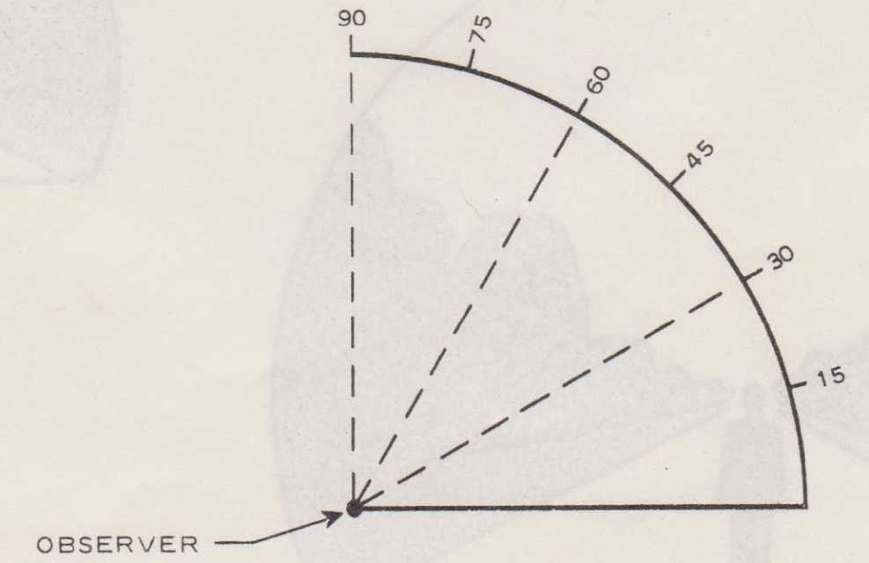
6a. Now imagine you are at the center of the compass rose. Place an “A” on the compass to indicate the direction to the phenomenon when first seen. Place a “B” on the compass to indicate the direction to the phenomenon when last seen.

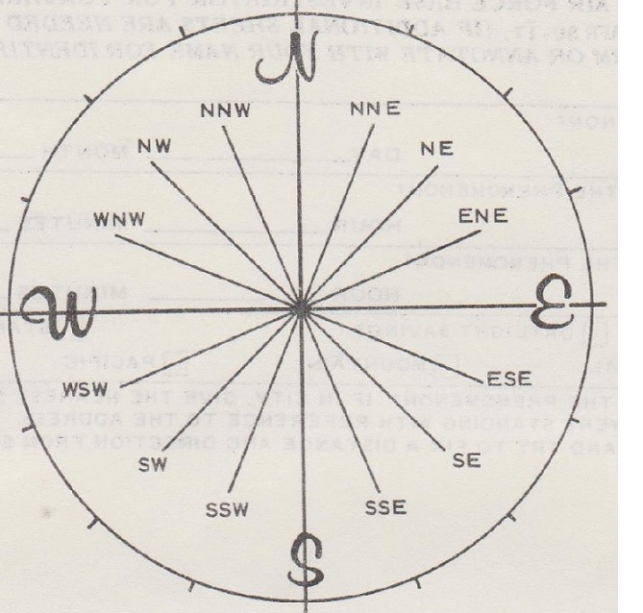

7. In the sketch below, place an “A” at the position of the phenomenon when first seen, and a “B” at the position of the phenomenon when last seen. Connect the “A” and “B” with a line to approximate the movement of the phenomenon between “A” and “B”. That is, schematically show whether the movement appeared to be straight, curved, or zig-zag. Refer to smaller sketch as an example of how to complete the larger sketch.

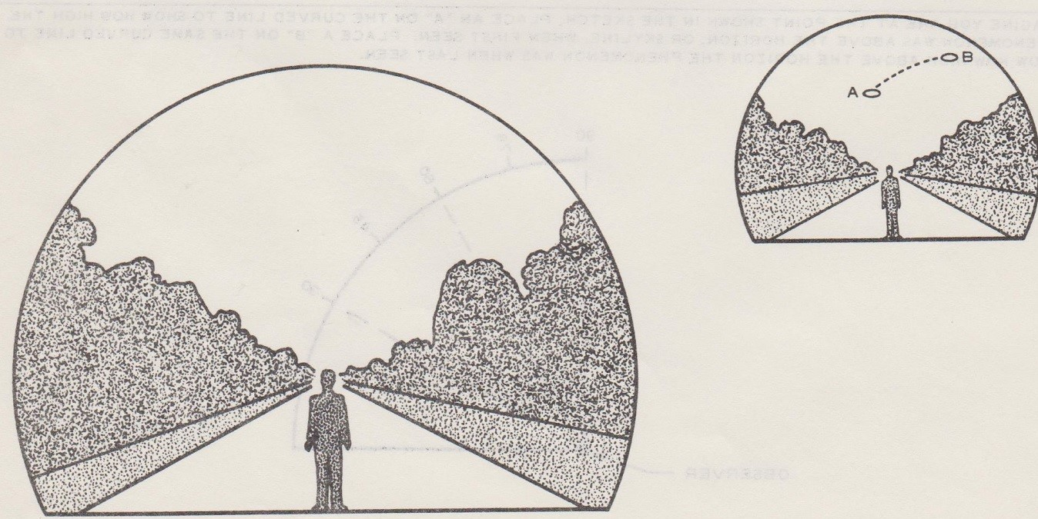
8. Where were you when you saw the phenomenon? (check all that apply)
 | Outdoors |  |  |  |  |  |  | In business section of city
 | In building |  |  |  |  |  |  | In residential section of city
 | In car |  | As driver |  |  | As passenger |  | In open countryside
 | In boat |  |  |  |  |  |  | Near airfield
 | In airplane |  | As pilot |  |  | As passenger |  | Flying over city
 | other |  |  |  |  |  |  | Flying over open country
 |  |  |  |  |  |  |  | other
8a. If you were in a vehicle, complete the following:
What direction were you moving? |  |  |  | How fast were you moving?
 | North |  | East
 | South |  | West | Did you stop anytime while observing the phenomenon?
 | Northeast |  | Southeast
 | Northwest |  | Southwest |  |  | YES |  | NO
Explain whether such movement affects your sketches in Items 5 and 6.

Describe type of vehicle you were in and type of road, terrain, or body of water you traversed during the sighting. State whether windows or convertible top were up or down.

How much traffic was there?

Did you notice any airplanes? Yes No If “yes”, Describe when they were in sight relative to the time of sighting the phenomenon and where they were in the sky relative to the position of the phenomenon.

9. How long was the phenomenon in sight?
Length of time |  | Certain of time |  | Not very sure
 |  | Fairly certain |  | Just a guess
How was time determined?
Was the phenomenon in sight continuously? Yes No If “No” indicate whether this is due to your movement or the behavior of the phenomenon, and describe such movement or behavior. Indicate disappearances on previous sketches.

10. If there were more than one phenomenon, how many were there?
Draw a picture to show how they were arranged. Did this arrangement change during the sighting?

11. Conditions (Check appropriate blocks.)
A. SKY |  | B. WEATHER
 | Day |  | Cumulus clouds (Low Fluffy) |  | Fog or MIst
 | Twilight |  | Cirrus clouds (High Fleecy or Herringbone) |  | Heavy Rain
 | Night |  |  |  | Light Rain or Drizzle
 | Clear |  | Nimbus clouds (Rain) |  | Hail
 | Partly cloudy |  | Cumulonimbus clouds (Thunderstorms) |  | Snow or Sleet
 | Completely overcast |  |  |  | Unknown
 |  |  | Haze or Smog |  | None of the Above
C. If the sighting was at twilight or night, what did you notice about the stars and moon?
(1) STARS |  | (2) MOON
 | None |  | Bright Moonlight |  | No Moonlight
 | A Few |  | Moon with Halo |  | Unknown
 | Many |  | Moon hidden by clouds
 | Unknown |  | Partial (New or Quarter)
D. If the sighting was in daylight, was the sun visible? Yes No If “Yes” Where was the sun as you faced the phenomenon?
 | In front of you |  | To your right |  | Overhead (Near Noon)
 | In back of you |  | To your left |  | Unknown
E. Specify the major source of illumination present during the sighting, such as the sun, headlights or streetlamp, etc.
For terrestrial illumination, specify the distance to the light source.

12. Give a brief description of the phenomenon, indicating whether it appeared dark or light, whether it reflected light or was self-luminous and what colors you noticed. Describe your impression of whether it was solid or transparent. Whether edges were sharp or fuzzy. Describe the shape or indicate if it appeared as a point of light. Indicate comparisons with other observed objects, like stars, a light or other object in your field of view.

13. DID THE PHENOMENON | YES | NO | UNKNOWN
Move in a straight line?
Stand still at anytime?
Suddenly speed up and run away?
Break up in parts and explode?
Change color?
Give off smoke?
Change brightness?
Change shape?
Flash or Flicker?
Disappear and reappear?
Spin like a top?
Make a noise?
Flutter or wobble?

14. What drew your attention to the phenomenon?

14a. How did it finally disappear?

14b. Did the phenomenon move behind or in front of something, like a cloud, tree, or building at any time?
YES NO If “YES” describe:

15. Draw a picture that will show the shape of the phenomenon. Include and label any details that might have appeared as wings or protrusions and indicate exhaust or vapor trails. Indicate by an arrow the direction the phenomenon was moving.

16. What was the angular size? Hold a match at arm’s length in front of a known object, such as a street lamp or the moon. Note how much of the object is covered by the head of the match. Now if you had been able to perform this experiment at the time of the sighting, estimate what fraction of the phenomenon would have been covered by the match head.

17. Did you observe the phenomenon through any of the following? Include information on model type, filter, lens prescription or other applicable data.
 | Eyeglasses |  | Camera viewer
 | Sunglasses |  | Binoculars
 | Windshield |  | Telescope
 | Side window of vehicle |  | Theodolite
 | Windowpane |  | Other
A. Do you ordinarily wear glasses? YES NO |  | B. Do you use reading glasses? YES NO
18. What was your impression of the speed of the phenomenon? Give estimate of speed _____________ |  | 19. What was your impression of the distance of the phenomenon? Give estimate of distance ____________

20. In order that we may obtain as clear a picture as possible of what you saw, describe in your own words a common object or objects which, when placed in the sky, similar to where you noted the phenomenon, would bear some resemblance to what you saw. Describe the similarities and differences between the common object and what you saw.

21. Did you notice any odor, noise, or heat emanating from the phenomenon or any effect yourself, animals or machinery in the vicinity? YES NO If “YES” describe:

21a. Did the phenomenon disturb the ground or leave any physical evidence? YES NO If “YES” describe:

22. Have you ever seen this or a similar phenomenon before? YES NO If “YES” Give date and location.

23. Was anyone with you at the time you saw the phenomenon? YES NO
If “YES”, Did they see it too? YES NO
23a. List their names and addresses

24. Give the following information about yourself
Last name, First name, Middle name

Address (Street, City, State and Zip Code)

Telephone (Area Code and number) | Age |  | Male |  | Female
Indicate additional information including occupation and any experience which may be pertinent.

25. When and to whom did you report that you had sighted this phenomenon?

Name_____________________________________ Day____________ Month________________ Year____________
26. Date you completed this questionnaire.
Day ____________ Month _______________ Year_____________
27. Information which you feel is pertinent, but which is not adequately covered in this questionnaire.
Alternatively provide a narrative explanation of the sighting.

